Coffee Mixer

Use this black coffee mixer to take your coffee from good to the best. Transform the milk into a creamy, airy and silky foam with this simple gadget. All you have to do is whisk the milk using this mixer and watch the milk transform to a foam. It is easy to use and even easier to clean.

£8.00

Metal Straws

Changing it up and having an iced coffee requires straws. So why not buy them here, where you can get 3 straws (two straight straws and one bent straw) with a cleaning brush to help keep the straws clean. They have a rounded edge and the metal straws will go well with any type of cold coffee.

£5.00

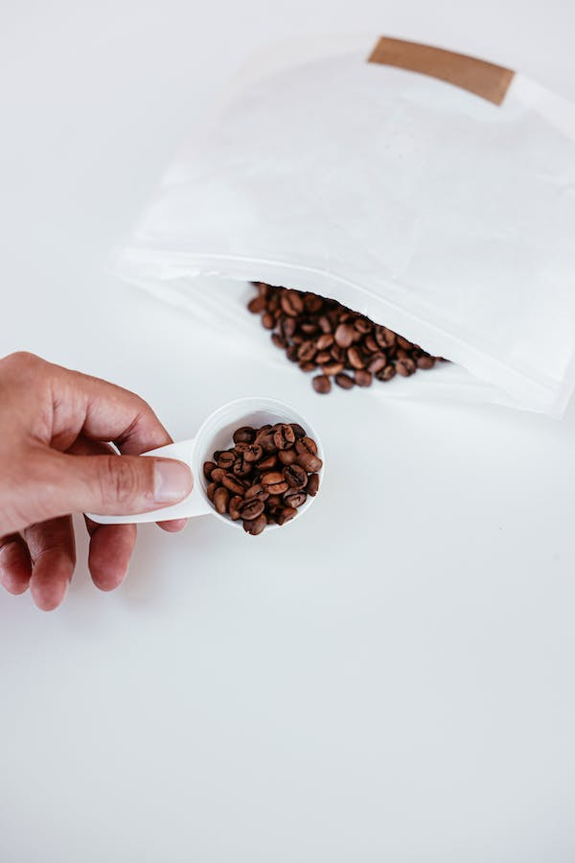White Measuring Spoon

Use this measuring spoon to help you get the perfect quantity of coffee beans every time you make your drink. With its sleek look and grip, it makes measuring your coffee easy.

£3.00

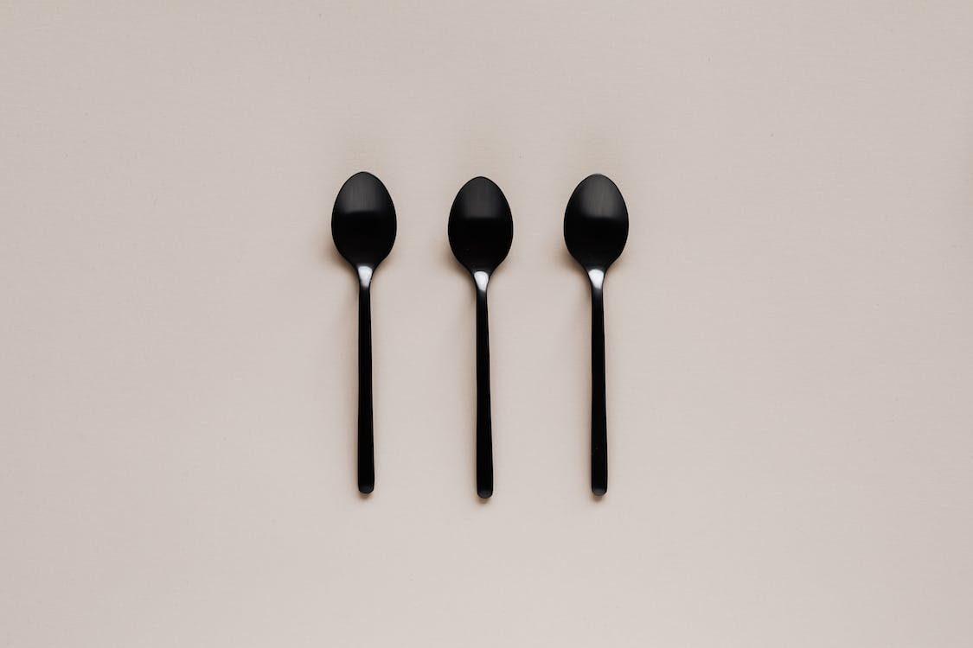Set of 3 Tablespoons

You can’t make or have a coffee without having spoons, either as a mixer or measurer. So buy your set of three black spoons here to elevate your experience as your own barista.

£5.00

Wooden Coaster – set of three

Protect your tables and your cups with our wooden coasters. They are not sharp or harsh on your tables meaning that it will protect them and stop the cups from scratching the surfaces.

£8.00